Text: II Peter 3:9 (KJV)
The Lord is not slack concerning his promise, as some men count slackness; but is longsuffering to us-ward, not willing that any should perish, but that all should come to repentance.

PERISH = Burning in Hell Forever

Ezekiel 33:11(NAS)
"Say to them, 'As I live!' declares the Lord GOD, 'I take no pleasure at all in the death of the wicked, but rather that the wicked turn from his way and live. Turn back, turn back from your evil ways! Why then should you die, house of Israel?'

I Timothy 2:4 (NAS)
who wants all people to be saved and to come to the knowledge of the truth.

Psalms 86:15 (NAS)
But You, Lord, are a compassionate and gracious God, Slow to anger and abundant in mercy and truth.

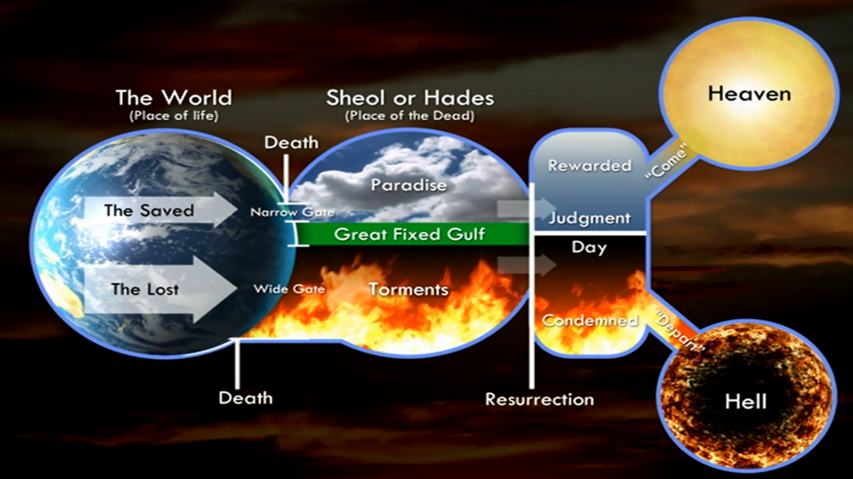

What the Bible Says About Hell:
- Hell is Prepared for the Devil and His Angels
- Hell is for Those Who Don’t Obey His Son, Jesus
- How the Bible Describes Hell

Point #1: Hell is Prepared for the Devil and His Angels

Matthew 25:41 (NAS)
"Then He will also say to those on His left, 'Depart from Me, you accursed people, into the eternal fire which has been prepared for the devil and his angels;

Point #2: Hell is for Those Who Don’t Obey His Son, Jesus
- Matthew 17:5 (NAS)
- Hebrews 5:8-9 (NAS)
- Luke 6:46 (NAS)

Matthew 17:5 (NAS)
While he was still speaking, a bright cloud overshadowed them, and behold, a voice from the cloud said, "This is My beloved Son, with whom I am well pleased; listen to Him!"

Hebrews 5:8-9 (NAS)
⁸ Although He was a Son, He learned obedience from the things which He suffered. ⁹ And having been perfected, He became the source of eternal salvation for all those who obey Him,

Luke 6:46 (NAS)
"Now why do you call Me, 'Lord, Lord,' and do not do what I say?

Point #3: How the Bible Describes Hell

Eternal Punishment and Torment

Final and Inescapable: Hell is presented as a final destination from which there is no return or escape, a grave warning about the consequences of rejecting God.
No Second Chances: The Bible indicates that death is a one-time event followed by judgment, and there are no opportunities for repentance or reconciliation after death.
Eternal Torment: Passages like Matthew 25:46 describe it as "eternal punishment," a concept supported by verses in Revelation about "eternal torment" and no rest "day or night".

Descriptions of Torment
A Place of Fire and Anguish: Hell is described as a "furnace of conscious torment" and a place of "excruciating misery" where the fire "never goes out" and the "worm does not die".

Anguish and Despair: The eternal nature of the torment means that despair can only increase over time, with no hope of it ever ending.

Separation From God: Hell is a state of being separated from the presence of God, who is the source of Romans 8:32 is a powerful verse that assures believers of God's complete provision based on the supreme sacrifice of His Son.

Commentators
Rom 8:32 emphasizes that this verse uses an argument from the greater to the lesser: if God gave His most precious gift, He will certainly provide everything else needed for salvation and spiritual welfare.

Key Themes and Interpretations
The Logic of Heaven (Greater to Lesser): The central argument is that the sacrifice of Jesus was the greatest act of love and giving possible. If God was willing to do the hardest and costliest thing (give His own Son), it is illogical to think He would withhold any "lesser" good or necessary thing from those for whom Christ died. This provides immense assurance of salvation and future provision, all comfort, peace, and life. In hell, there is no mediator, only God's wrath, leading to increasing despair.

All we have to do is truly want to be saved. not to be cast into the eternal fire.

Philippians 2:13 (AMPC)
[Not in your own strength] for it is God Who is all the while effectually at work in you [energizing and creating in you the power and desire], both to will and to work for His good pleasure and satisfaction and delight.

RESPONSE TO THE INVITATION OF FAITH:
1. HEAR the GOSPEL ~ Romans 10:17
So then faith cometh by hearing and hearing by the word of God.
2. BELIEVE ~ Hebrews 11:6
But without faith it is impossible to please Him, for he that cometh to God must believe that He is and He is a rewarder of them that diligently seek Him.
3. REPENT ~ Luke 13:3
I tell you nay; but except ye repent ye shall all likewise perish.
4. CONFESS ~ Matthew 10:32-33
Whosoever therefore shall confess me before men, him will I confess also before my Father which is in heaven. But whosoever shall deny me before men, him will I also deny before my Father which is in heaven.
5. BE BAPTIZED ~ Acts 22:16
And now why tarriest thou? arise, and be baptized, and wash away thy sins, calling on the name of the Lord.

